

Casterton and District
Historical Society Inc Newsletter

March 2011



Historical Happenings

Items in our newsletter:

Crossroads of Casterton
by Jim Kent page 1-2
Federation of Australian Historical Societies news page 3



Casterton Community Museum

Crossroads of Casterton
by Jim Kent

CHANGE OF MEETING DATE

The March meeting will be held during the day on the 4th Thursday as the president will be away on holiday on the usual date.

We will meet on Thursday 24th March 2011at the RSL at 2pm.

Floods 1946
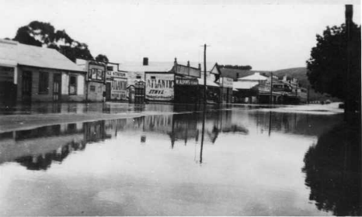
Schoolroom, Casterton, date unknown
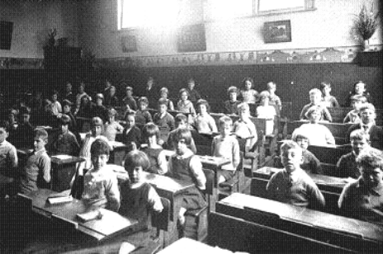Does any recognize any of the pupils?

Some years back an American author wrote quite a romantic story based on the covered bridges of Madison country. Now here at Casterton we don’t have covered bridges to write about but we do have crossroads, plenty of them, within our town’s boundary. Also I cannot conjure up a romantic liaison with them but I can, by writing about them, possibly prompt some remedial action by those who have the responsibility of the duty of care.
By that I am referring to local government and the army of assistants they have ensconced in their headquarters at Portland all decked up under various headings which give them quite some bureaucratic leverage when dealing with their rate-paying subjects.
By blaming previous local government for the current dangerous state of some of these crossroads does not, nor will it tend to exempt them from what will inevitably happen when an accident occurs, with possible fatal results, at one of these dangerous crossroads.
Just try building some form of edifice without a permit and see how you get on – a fence, a carport, a shed, a house – can cause you to submit in detail the combination of various components you propose to use in the construction, plus the drawings, and environmental effects must be elaborated.
Yet here we are subjected daily to horrendously dangerous crossroads, whilst those that are paid to plan safe roadways apparently are quite content to turn a blind eye to this potentially dangerous situation.
Go for a drive around our town and see for yourself what I am writing about. Go up Murray Street and at some crossroads you have right of way, some you don’t. Why is this so? Why not take the same law all the way up this street?
Try the Robertson Street-Shiels Terrace one but be sure to have your wits about you when you do have a go as speed limits are largely ignored. Peachey Street into Carmichael Street is completely blind at the corner rendered thus by shrubbery.

Page 2 of 3

Historical Happenings

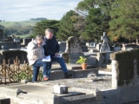

Casterton New Cemetery Mapping Project

We have now completed all sections - Jan needs to finish up doing the bits and pieces on the computer, then we will walk again to re-check.

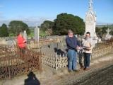

And for a humdinger of a most dangerous crossroads have a go at getting across Anderson Road from the Racecourse Road – sheds, yards, trees and shrubbery almost completely prevent you from ascertaining other traffic using this crossroad.
Maybe this bit of a whinge of mine relative to the state of the town’s crossroads will prompt some of you to direct the attention of the appropriate authorities to this situation. I am afraid that as I am persona non grata at Glenelg Shire headquarters any attempt by me would be ignored. Past attempts by me on other matters have not been successful.
As the writer of this article I accept full responsibility for the comments expressed therein and in no way can the reflection be aligned to the Casterton Historical Society, of which I am a member. The Society reserves the right to express its own opinion on any matter whatsoever.
oooooooo00000000000000ooooo

Request from Daryl Povey:

Is anyone able to identify Robert KERR, who according to Billis & Kenyon "Pastoral Pioneers of Port Phillip"...
...arrived. Port Phillip, May 1836;
...occupied "Chetwynd" Pastoral Run Sept. 1843 to Sept. 1845;
...occupied "Foxhall" Pastoral Run 1848.
Both runs are N or NW of Casterton, S-W Vic
Matthew Flinders' 1804 map of Australia
At 11am on 25 January 2011, in front of St Paul’s Cathedral in Melbourne, the President of the Federation of Australian Historical Societies Inc, Assoc Professor Don Garden, joined the Victorian Education Minister, the Lord Mayor of Melbourne and the Member for Flinders in the Australian Parliament to launch a call for bringing home to Australia Matthew Flinders’ 1804 map of Australia. 2014 is the bicentenary of the death of Flinders.
The 1804 Finders map is significant for Australia as a nation. Flinders was commissioned in 1801 by the British government to chart the previously unmapped regions of the ‘great south land’. Flinders completed his circumnavigation and rough charting in 1803. He completed the map in 1804 while detained at Mauritius and sent it to England. His account of his explorations, Voyage to Terra Australis and the first map of Australia were published in 1814. This is the map that is normally reproduced. In 1817, Governor Macquarie recognized Flinders’ preference for the name ‘Australia’, and adopted the name himself. As the original map Flinders drew in 1804 is a priceless part of our national heritage, it is important that it be returned to Australia and exhibited. An online petition is available at the following link: Petition to the British Parliament – Bring Home the Birth Certificate of Our Nation

We’re on the Web - visit us at:

www.ballaratgenealogy.org/
casterton/historicalsociety

New magazine - Inside History
www.insidehistory.com.au

The publication is aimed at people passionate about history and heritage, whether it’s their own family’s ancestry, or in a broader social context. Published bi-monthly, Inside History provides insightful, interesting and practical features to its readers.

Its 70 pages are packed with advice, articles and expert tips on genealogy, and stories on Australia’s varied history, from tales about century-old houses and Australia’s country towns, to heritage gardens and the biographies of famous (and infamous) citizens.

On-line Australian Historical Societies Support Group

The online Australian Historical Societies Support Group is one of the My Connected Community (mc2) groups initiated and funded by the Victorian Government’s Connecting Communities policy.

The Australian Historical Societies Support Group offers participating historical societies, like-minded bodies and their members a variety of free, easy to use Web-based services which they can use to communicate with each other across the nation and the world on any topic that is of interest or concern to their organisations.

The mc2 website provides easy access to online technologies now available for communicating between group members. Features of mc2 include a forum, an events list, space for sharing files, space for sharing photos, a links page and a chat room.
Details on how to join the Group are available at the FAHS website at: www.history.org.au. (Source: FAHS Council)
Parramatta Female Factory
There has a brief report on ABC 1 NSW news recently regarding the Parramatta Female Factory. It was a response to the Museums Australia New South Wales media release about the proposed installation of IT equipment and air conditioning units in this Greenway built, heritage building by the Sydney West Area Health Service. Both Andrew Simpson, President of the Museums Australia NSW and Gay Hendriksen were interviewed.
For those interested in checking the blog on the Female Factory Precinct, which includes the Parramatta Female Factory, the Catholic Orphan School and the Girls' Industrial School, see http://femalefactoryprecinctactiongroup.wordpress.com.
There is a petition to support the Female Factory Precinct Action Group, with the aim to have the Parramatta Female Factory Precinct returned to the people of Australia at http://petitionbuzz.com/petitions/savethefemalefactory.
(Source: History Council of Western Australia - Email Round-up 4 February 2011)

Page of 3 33



Our Address

PO Box 48, Casterton, 3311

Phone: 5581 2070

Casterton Visitor Information Centre

e-mail:
jlier3@bigpond.com
roscov48@bigpond.com
To contribute to this newsletter, please contact Jan Lier
at the Visitor Information Centre on 5581 2070 or
e-mail
jlier3@bigpond.com
or Ros roscov48@bigpond.com
tel 5581 2875

