


Casterton and District
Historical Society Inc Newsletter

JUNE 2011

Historical Happenings

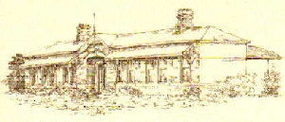

Items in our newsletter:

The Railway That Wasn’t page 1-2
More about flax page 2
An early pioneer: Cuthbert Fetherstonhaugh page 2-3

ms in our newslett:

Casterton Community Museum

The Railway That Wasn’t
by Jim Kent

After much agitation, public meetings, lobbying of local, state and commonwealth politicians, eventually the railway spur line from Branxholme arrived in Casterton in 1884, to the great delight of the residents of the town and its close environs. Not all the local district rejoiced in its advent. Those residing in the southern districts through which the steel railroad ran were quite happy, whilst those to the north and east were starting to stir with ambitions to have these rail lines continue from the terminus at Casterton.

With a railroad running parallel to the border of the state of South Australia and Victoria, those who lived and farmed west of Casterton had access to this means of transport even if it meant their produce veered away to the SA cities and towns. This state of affairs gave rise to the more prominent residents of the Dergholm-Elderslie area to the north, and ditto the Chetwynd-Edenhope area, to form what came to be known as the “Railway Leagues”. Even the relatively obscure settlement of Brimboal formed a Railway League, as did a very vocal group of Chetwynd residents. As is often the case with humans, much argument was recorded between the members of the Railway Leagues centering mainly on to just where this line would continue from the Casterton railhead.

The Dergholm League decided that the rail line should follow the course of the Glenelg River to Dergholm, then continue on Apsley, before joining the SA rails systems. Not to be outdone, the Chetwynd League wanted the railroad to follow the Glenelg River’s west bank to Nangeela then a bridge over the river would put it on the east river bank, and from there through to Burke’s Bridge and to join up with the Kaniva rail line north of Edenhope. Just how the proposed rail line on the banks of the flood-prone Glenelg River would handle the wet weather did not seem to have been taken into the equation - nor did the problem of getting it over the hill at Henty Street, the neighbouring Murray, Addison, Kirby and Sprigg Streets, plus the Dunrobin road.

While all this to-ing and fro-ing was taking place from the late 1880s, many harsh words were spoken and vitriolic lines were written by members of the various Leagues citing the various attributes of particular districts. In the early decades of the 1900s closer settlement of some large estates of land took place, as did the Soldier Settlement Scheme of landholding after the 1914-18 Great War.

NEXT MEETING DATE
We will meet next in August for the AGM.

Please note the new email address for Jan Lier is jlier3@activ8.net.au

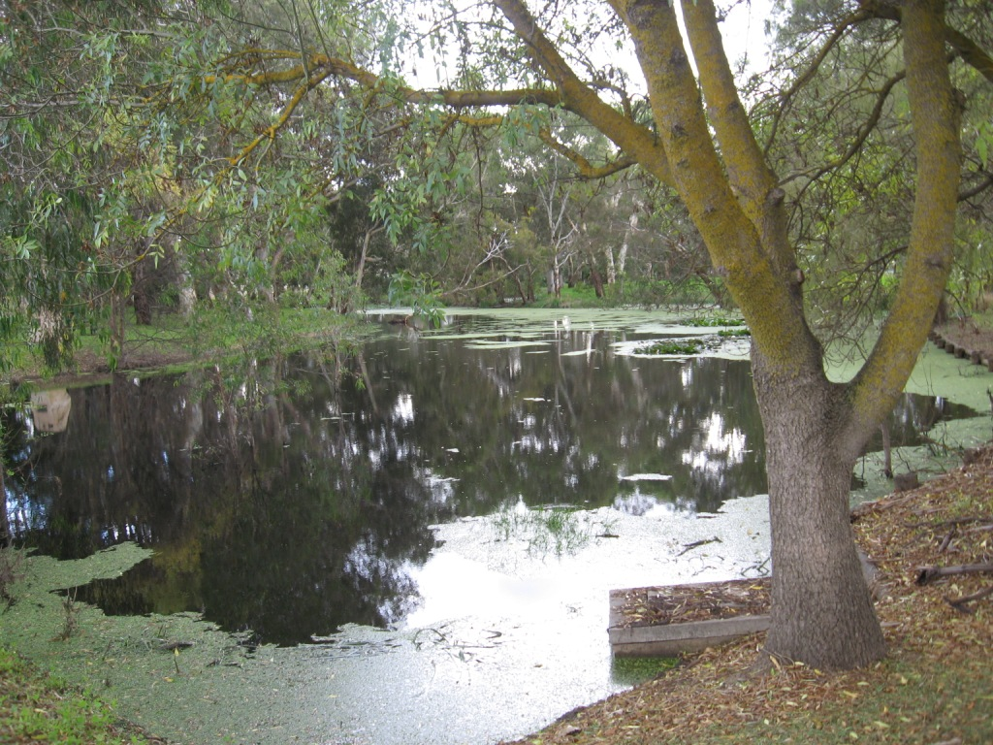

Casterton New Cemetery Mapping Project: continuing
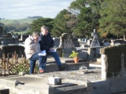

We will soon walk all again to re-check details - and photograph the headstones.

Page 2 of 3

Historical Happenings

Page 2 of 3

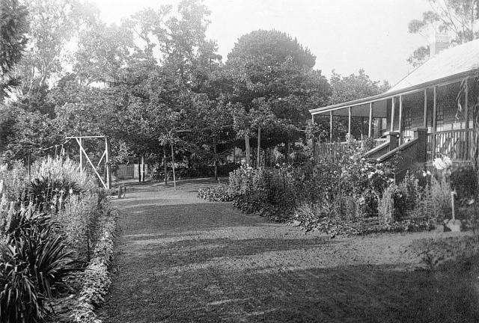

Merino Downs in 1920

Cuthbert Fetherstonhaugh

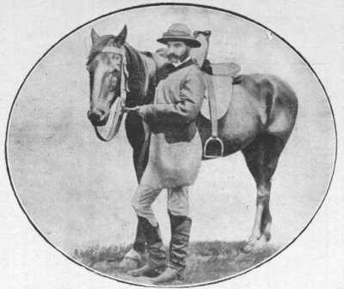

These factors accelerated the move to have the rail lines extended to facilitate the movement of primary produce away from the ponderous method of animal-drawn wagons. It is known that a rail line was surveyed as far out as Nangeela, ancient survey pegs proving this fact. With the arrival of the motor truck the Railway Leagues died a natural death by the mid 1920s. §
An update to The Tangled Past of Flax, about flax-growing in the area published in our May issue. The Casterton News on 9th December 1944 printed this report regarding the local flax industry: “In the face of almost nation-wide failure for the year…the success in this area is remarkable. Mr Alex Lee of the Commonwealth Flax Production Committee said that he had within the last few weeks visited Western Australia, South Australia and most of Victoria but he had come to Casterton to find crops of championship standard. These results have been achieved over very diversified types of soil and give promise of development almost without limit of this very lucrative industry throughout the district. Such success, in view of the vital importance of this commodity in the present national crisis, must surely evoke official notice of the proved stability of production in the Casterton district. Three of the entries in the State competition are Murphy Bros of Dunrobin, W H Mitchell of Sandford and P Carey of Nareen who will vie for the honour of championship of the State”. §
Cuthbert Fetherstonhaugh in his book "After Many Days" written in 1917 reminisced about his time at Muntham from 1856 - 1862.
In 1834 two of the brothers, Edward and Frank Henty, came over to Portland Bay in connection with a whaling venture. They settled there, and got over some horses, cattle and sheep. Two years after-wards they were followed by another brother, Stephen George Henty, who also settled in Portland Bay, and who, for many years, was the leading merchant of Portland-a man whose word was his bond, and whose beautiful home was always open to a host of friends. He afterwards went to Melbourne, and resided there for many years. His widow, beloved and respected by all who had the privilege of knowing her, lived at Hamilton with her daughter, Mrs Stapyleton Bree, up to the time of her death. Their son, Richmond, was born the year Muntham and Merino Downs were taken up. One daughter, Emily, married my great friend, Dr. T. M. Wyley, a fine, handsome fellow. He succeeded Dr. Wyman at Casterton. He went through the Crimean War, an army surgeon In the same regiment with Major Pennycuick, who married a daughter of William Rutledge, of Port Fairy. Mrs Wyley died at Hamilton within a year of her marriage, and poor Wyley only survived her a year or two.
James Henty, another brother, came to Port Phillip later on, and was successful in Melbourne in business in a large way. There was another brother, John, and still another brother, William, who went into politics, and was for some years Chief Secretary of Tasmania. I knew only the three pioneers, Edward, Frank and Stephen. Rolf Boldrewood writes of the Hentys as “those representative Englishmen and distinguished colonists who commenced the Anglo-Saxon conquest of Australia Felix. Stalwart and steadfast were they, well fitted to contend with the rude forces of nature and still ruder individuals, among which their lot was chiefly cast in those days. But withal genial, hilarious, and in their moments of relaxation prone to indulge in the full swing of those animal spirits which for the most part accompany a robust, bodily and mental organisation."

Island Park Lagoon

We’re on the Web - visit us at:

www.ballaratgenealogy.org/casterton/historical
society
In 1836, while still at Portland Bay, the Hentys were greatly surprised by Major Mitchell, the brave and capable explorer, tumbling right in on them quite unexpectedly from the north. The Major was equally surprised to find Portland Bay in the occupation of whites, and at first thought they must be escaped bushrangers. Even in my time in more than one place I have seen the Major's track, being the indent made in the soft virgin soil by the wheels of his bullock dray. The Major reported that he had passed through magnificent pastoral country, well watered, about fifty miles to the north, and as the country about Portland was not good sheep country, a good deal of it being sand covered with heath, while the forest land was so thickly timbered as to preclude the growth of grass, the brothers determined, like the patriarchs of old, to trek for the promised land, with their sheep, cattle and horses.
Having satisfied themselves of the magnificent character of the country described by Major Mitchell, Edward and Frank Henty, whose sheep, brought over from Tasmania to Portland Bay, had by this time considerably increased, decided to make for these pastures new, and in the latter part of 1847 Merino Downs and Muntham were taken up.
In the following year Samuel Pratt Winter and his brothers, Trevor and George, came over from Tasmania, and took up Tahara and Murndal, all rich volcanic land that cannot well be surpassed. Murndal, as Sam Winter called his homestead, is one of the most beautiful places in the Far West. It was a most delightful house to visit when the two bachelor brothers lived there, and no less delightful of late years, when Samuel Winter Cooke and Mrs Cooke so hospitably and kindly entertained their many friends
Winter told me that when the diggings broke-out in 1851, and labour was not to be had, he put all his sheep into two flocks, and two magnificent St. Bernard dogs used to take the sheep out all day and look after them and keep them apart, and then at night these grand dogs used to sleep between the two flocks and guard them. Winter was a most delightful main to meet, intellectual, kind, and generous. He, like Acheson Ffrench, very early adopted the Darwinian teaching, and consequently both were looked upon with great suspicion by the orthodox; indeed, as already stated, Ffrench was designated an atheist because he professed belief in what the majority of educated clergymen now teach from their pulpits. Parson Russell, whose parsonage was not far from Murndal, and built on land presented by Sam Winter, must have had many a discussion with the latter on this and other interesting subjects. They were fast friends. Dr. Russell was not only clever and intellectual, but one of the best men I ever knew.
Frank Henty lived at Merino Downs for many years, and brought up a family of three girls, and one Joy; the latter died young, but two of the "girls" still survive. Kinder or more considerate host and hostess than Mr. and Mrs. Frank were not to be met with in those dear old days, when there was no ceremony, and but little conventionality, and when a visitor could always be sure of a hearty welcome, and the only difficulty was to get away again.
At the time the Henty's put stock on the rich Wannon country (1837), there was but little settlement elsewhere in Port Phillip, as Victoria was then called. In the December of the previous year (1836) Hepburn and party had arrived at Hobson's Bay overland from Sydney, and they found, as Hepburn says in a letter to Governor Latrobe, "only a few huts in the settlement; one was that occupied by Batman, one by Dr. Thomson, one little wooden box was occupied by Strachan, and stood where the Western Market now stands. The Old Iamb Inn was being built, but no accommodation of any sort was to be had for love or money. Buckley was the first man I saw." To be continued…

Page 3 of 3 33



Our Address

PO Box 48

Casterton 3311

Phone: 5581 2070

Casterton Visitor Information Centre

e-mail:
jlier3@activ8.net.au
roscov48@bigpond.com
To contribute to this newsletter, please contact Jan Lier
at the Visitor Information Centre on 5581 2070 or
e-mail at her NEW address
jlier3@activ8.net.au
or contact Ros at roscov48@bigpond.com
tel 5581 2875

